STUNDENT MARKETPLACE
INTRODUCTION:
This is a website that is exclusively for students to buy and sell products in between students. For affordability reasons.
OBJECTIVES:
The objective of this website is to provide a site where students can sell and buy items such as Textbooks, electronics and other student related materials in a simple and cheap manner.
GOALS:
- To provide a user friendly market place .
- To help students save money by buying second hand items.
- To provide students with a platform to sell unused items.
TARGET AUDIENCE:
The audience I am aiming for are students under the ages of 18-30.Specifically those in Universities.
TECHNICAL APTITUTE:
They are expected to have a basic technical capability of internet/website browsing, Identifying and filling forms and also basic usage of mobile devices.
TYPE OF WEBSITE:
This will be an E-commerce or a Marketplace website that will be focused on student-to-student buying and selling.

INFORMATION DESIGN & TAXONOMY
WEBSITE PAGES ( STRUCTURE)
Home(index)
About
Contact
Products
Sell Items

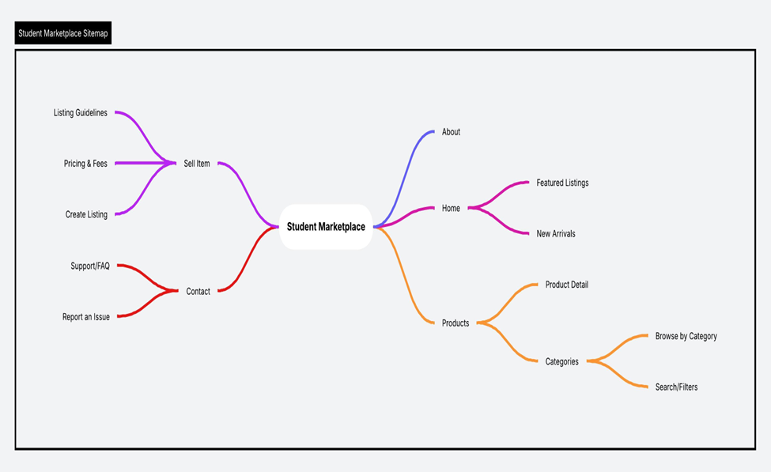

TEMPLATE DESIGN

TECHNICAL BRIEFING
HTML5
CSS3
BOOTSTRAP
JAVASCRIPT
VISUAL STUDIO CODE
GITHUB

QUALITY ASSURANCE
Browser Testing:

Google Chrome
Microsoft Edge

Mobile Testing:
Android devices
Different screen sizes

PUBLISHING & PROMOTING
Process:

Create a GitHub repository

Upload website files (HTML, CSS, images)

Use Git commands:
git init
git add .
git commit -m "Initial commit"
git push

Enable GitHub Pages in repository setting

FUTURE DEVELOPMENT

Adding user login and registration
Implementing online payment options
Adding chat functionality between buyers and sellers
Improving design with animations and advanced features
Expanding product categories

